

American International University-Bangladesh (AIUB)  
**Department of Computer Science  
Faculty of Science & Technology (FST)**

**COMMUTE BUDDY**

A Software Engineering Project Submitted

By

|  |  |  |  |  |
| --- | --- | --- | --- | --- |
| **Semester: Summer 22-23** | | **Section: E** | **Group Number: 07** | |
| SN | Student Name | Student ID | Contribution (CO1+CO2) | Individual Marks |
| 01 | RAIYAN RAHMAN KHAN | 17-35963-3 | 20% |  |
| 02 | MD. IYEASIR ARAFAT | 19-41374-3 | 20% |  |
| 03 | SAFIN KHAN | 21-45715-3 | 20% |  |
| 04 | TANVIR SHAAD | 21-45716-3 | 20% |  |
| 05 | SK MD ASIF NEWAZ | 21-45732-3 | 20% |  |

The project will be Evaluated for the following Course Outcomes

|  |  |  |
| --- | --- | --- |
| CO1: *Analyze* the impact of software engineering models over various context of software development to assess societal, health, safety, legal and cultural issues. | Total Marks | |
|  | |
| Project Background Analysis and feasibility (needs, goal, benefits, etc.) | [5 Marks] |  |
| Analysis the impact of societal, health, safety, legal and cultural issues | [5Marks] |  |
| Review of existing Studies and Relevant Example | [5Marks] |  |
| CO2: *Explain* appropriate software engineering model, project management roles and their skills in the context of professional engineering practice and solutions to complex engineering problems in a software development environment. | Total Marks | |
|  | |
| Appropriate Process Model Selection and Argumentation with Evidence | [5Marks] |  |
| Evidence of Argumentation regarding process model selection | [5Marks] |  |
| Submission, Defense, Completeness, Spelling, grammar and Organization of the Project report | [5Marks] |  |

Description of Student’s Contribution in the Project work

|  |
| --- |
| Student Name: RAIYAN RAHMAN KHAN  Student ID: 17-35963-3  Contribution in Percentage (%): 20%  Contribution in the Project:   * Contributed to identifying Problem background. * Contributed to finding solutions to the problem.   *Raiyan*  ___________________  Signature of the Student |
| Student Name: MD. IYEASIR ARAFAT  Student ID: 19-41374-3  Contribution in Percentage (%): 20%  Contribution in the Project:   * Contributed to designing Use case diagram. * Contributed to writing the solutions to the program.   *Iyeasir*  ___________________  Signature of the Student |
| Student Name: SAFIN KHAN  Student ID: 21-45715-3  Contribution in Percentage (%): 20%  Contribution in the Project:   * Contributed to designing Activity Diagram * Contributed to Proposal Writing.   *Safin*  ___________________  Signature of the Student |
| Student Name: TANVIR SHAAD  Student ID: 21-45716-3  Contribution in Percentage (%): 20%  Contribution in the Project:   * Contributed to designing Sequence Diagram. * Contributed to identifying suitable process model. * Contributed to all mathematical analysis and calculation. * Contributed to test planning. * Contributed to creating risk table.   *Tanvir*  ___________________  Signature of the Student |
| Student Name: SK MD ASIF NEWAZ  Student ID: 21-45732-3  Contribution in Percentage (%): 20%  Contribution in the Project:   * Contributed to designing Class Diagram. * Contributed to identifying Functional Requirements.   *Asif*  ___________________  Signature of the Student |

## Rubric for Project Assessment (CO1)

|  |  |  |  |  |  |
| --- | --- | --- | --- | --- | --- |
| Marking Criteria | Marks Distribution (Maximum 3X5=15) | | | | Acquired Marks |
| **Inadequate (1-2)** | **Satisfactory (3)** | **Good (4)** | **Excellent (5)** |
|  |  |  |  |  |  |
| Background  Analysis | No background information regarding the project is  given; project goals and benefits are  missing. | Insufficient background information is given; project goals and benefits are  poorly stated | Sufficient background information is given; the purpose and goals of the project are explained. | Thorough and relevant background information  is given; project goals are clear and easy to identify. |  |
| Analysis the impact of societal, health, safety, legal and cultural issues | Student vaguely discuss the impact of societal, health, safety, legal and cultural issues in their project | Student provided with partial relevance to the impact of societal, health, safety, legal and cultural issues in their project | Student fairly provided the analysis to the impact of societal, health, safety, legal and cultural issues in their project | Student comprehensively provided the analysis to the impact of societal, health, safety, legal and cultural issues in their project |  |
| Existing Studies and Relevant Example | Ambiguous representative example. | Partially identify / indicate towards real-life example. | Real-life example is fairly connected towards the definition. | Comprehensively defend with real life example. |  |
| Acquired Marks: | | | | |  |
| CO Pass / Fail: | | | | |  |

## Rubric for Project Assessment (CO2)

|  |  |  |  |  |  |
| --- | --- | --- | --- | --- | --- |
| Criteria | Marks distribution (Max 3X5= 15) | | | | Acquired  Marks |
| **Inadequate (1-2)** | **Satisfactory (3)** | **Good (4)** | **Excellent (5)** |
| Argumentation of Model selection with Evidence of Argumentation | Does not articulate a position or argument of choosing appropriate model. Does not present any evidence to support the arguments for the choice of the model | Articulates a position or argument for choosing models that is unfocused or ambiguous. Presents incomplete/vague evidence to support argument for model choice | Articulates a position or argument of choosing models that is limited in scope. Does not present enough evidence to support the argument for the choice of the model | Clearly articulates a position or argument for the choosing software engineering models. Presents sufficient amount of evidence to support argument for the model selection |  |
| Role identification and Responsibility Allocation | The project has poor project management plans for identifying roles and assigning the responsibilities | Identify few roles in the project management where some of the roles are left alone with any project responsibilities | Identify most of the roles in the project management and assign their responsibilities | Well planned project with proper role identification and responsibility allocation in the project management activities |  |
| Submission, Completeness, Spelling, grammar and Organization of the Project report | Project report is not complete and Several errors in spelling and grammar. Present a Confusing organization of concepts, supporting  arguments, and  real-life example.  Sentences rambling, and details are repeated. | Some errors in spelling and grammar. Some problems  of organizing the answer in a logical order of defining,  elaborating, and providing real-life examples. | Few errors in spelling and grammar. Presents most of the details in a logical flow of  organization in  definition,  details, and  example. | Project report is complete and No errors in spelling and grammar. Consistently  presents a logical  and effective  organization of definition,  details, and real-life example of  the topic. |  |
| Acquired marks: | | | | |  |
| CO Pass / Fail: | | | | |  |

# PROJECT PROPOSAL

## Background to the Problem

Overpopulation is the number one problem of our country. Besides, the overly congested urbanization of the poorly planned capital Dhaka city has led to a serious transportation crisis in the city. In addition, the poor road condition and poor traffic management has made intra city commute a regular nightmare. To address this serious issue some measures were taken but yet they were not enough to fully resolve the issue.

On the roads of Dhaka, it is commonly seen that most of the personal vehicles are commuting either half or full empty which is a crucial problem considering the over congested traffic situations throughout the streets of a densely populated city like Dhaka.

The Commute Buddy application can connect urban commuters with common starting location and common destination and contribute to reduce the ever-growing demand of intra city transportation.

To solve this issue the problem needs to be addressed dynamically with the help of technology.

The Commute Buddy application is one such application.

The goal of the Commute Buddy application is to enable the user to share their day-to-day commuting routine with their friend and family or selected contacts from their phone’s contact so that upon having a common starting location and common destination the application will notify the matching users and help them communicate and share a trip.

## Solution to the Problem

The major objective of this project is to allow the users to share their daily commuting route and schedule with their preferred contacts to address growing demand of urban transportation.

The motto of the Commute Buddy application is: “No vehicle should travel empty”.

The application provides solutions to a series of serious issues by connecting mutual group of commuters and allowing them to travel together reducing the need of extra vehicle on the road and reducing insufficiency that of a regular personal vehicle.

The Commute Buddy application allows the users to share their daily commuting route and schedule with their preferred contacts and ultimately share a trip to their common destination with one of the matching user’s private vehicles.

For tracking the users GPS technology can be used other than that,

Advanced routing algorithm can be used to merge multiple user’s destination and decide to pickup/ drop off locations.

* The resulting application will help connect a group of people and ultimately increase socialization between mutual individuals.
* The application will allow users to travel in safe private transportation avoiding the health hazards of using public transportation and also reducing the emission of Carbon di-oxide due to reduced need of extra vehicle for each individual.
* The Commute Buddy application enables the users to share trips with their trusted known individuals. The application’s functional approach greatly improves women’s safety compared to that of local public transportation.

The initial target group of users for this application are Students, private and govt. job holders who have a periodic weekly fixed routine from their home to their school/ work destination.

This project can contribute to collecting user time schedule data and can further help identify busiest routes throughout the city or to perform analytical research on the city’s transportation needs to further improve road traffic infrastructure.

There are already some existing softwires in our community such as Pathao or Uber which allows their users to share ride with another user which can also bring a solution to the over congested traffic situations.

But the examples are commercial application and only allocates one driver to one user in change of money to chauffeur the user on their demand. but the Commute Buddy app excludes the economic transactions and contributes to lowering traffic congestion by allocating a connected group of people to one vehicle.

**Process Model:**

Commute buddy is a versatile application, where requirements may change frequently. The project scopes are limited in size. Therefore, the attributes are best suited for SCRUM.

It is a ride sharing application based on multiple different regions with different set of rules and regulations which may require frequent changes on the software to meet certain regional regulations. For which the project’s development would not be suitable for plan driven processes such as waterfall, iterative methods. Because these models require the project to have a fixed set of requirements.  
The project also would not be suitable for XP because the project has limited set of scopes and a small group of developers.

**The roles for Scrum Process are:**

**Product owner**Product owner is the one person who is responsible for the product. All product requirements for the developers must come through this role. The list of requirements for the product is gathered in a product backlog, which the product owner is responsible for. The product owner also determines the priorities of these requirements and ensures the requirements are clearly defined

**Scrum Master**  
Scrum master makes sure the scrum team adheres to scrum practices, by assisting the product owner and the development team. For the product owner, this help includes suggesting techniques to manage the product backlog, to attain clear requirements, and to prioritize for maximum value. For the development team members, this help includes coaching the team to self-organize and remove roadblocks. The scrum master also facilitates the four events listed above within a sprint.

**Scrum Development**  
Scrum Development Team are the developers on a scrum team, also known as the scrum development team, must be self-organizing. No one outside the development team, not even the scrum master or product owner, tells them how to turn the backlog of requirements for a sprint into developer tasks to produce an increment of working software. Scrum development teams are small, ideally between three and nine people. They are self-contained, consisting of everyone and everything needed to complete the product. Also, each member generally takes on mixed tasks, like doing both coding and testing, rather than having dedicated coders and testers. There are no special sub-teams. Everyone on the team is responsible for the team’s work products. Accountability rests with the entire team.

**Functional Requirements**

1. **Commute Buddy application Registration Requirements:**
   1. Commute Buddy application shall allow users to sign up on the platform using unique email address/ phone number and password.
   2. Along with email address/ phone number and password, Personal validation data (such as: first name, last name, age, address, national ID card no, driving license no, vehicle registration number and vehicle identity code) will be collected during the registration process.
   3. Upon collection, unique email id/phone number shall be verified by using confirmation e-mail or OTP.
   4. The platform will only allow registration if there are no existing account based on the provided email address or phone number.
   5. If user does not own a personal vehicle, then some of the personal data such as: driving license no, vehicle registration and vehicle identity code will be ignored and functionality will only be limited to Request On-board [reference : 3.2] only.
   6. User will only be allowed to register after filling all the required fields.
   7. Upon registration user data and identification shall be verified by an administrator before user account activation.
   8. Upon successful registration, the home page of the user account will be displayed and the user will be waiting for administrator approval for account activation.
   9. User activities inside of the application shall be limited until user is activated.

Priority level: High

Precondition: Provided email-address or phone number must be unique , all the required field must be filled.

Cross references: 4.1 , 4.5.

**2. Software Login Requirements:**

2.1 Commute Buddy system shall allow users to login with their email address/phone number and password.

2.2 The login credentials (e-mail/phone-no and password) will be verified with database records.

2.3 If the login successful the home page of the user account will be displayed.

2.4 If the username and/or password has been inserted wrong, the random verification code will be generated and sent to the user’s email address by the system to retry login.

2.5 If the number of login attempt exceed its limit (3 times), the system shall block the user account login for one hour [optional function]

Priority Level: High

Precondition: user have valid user id and password

Cross-references: 4.1, 7.2

**3. Set weekly routine requirements:**

3.1 After logging in, Commute Buddy application shall allow users to upload their traveling route from and to using map API along with valid time schedule.

3.2 upon saving schedule, a user can choose either one option from the ride share options.

1. Request On-board

2. Welcome On-broad.

3.3 depending on user’s choice from the ride share options, user will be forwarded to different functionality panel.

Priority Level: Moderate

Precondition: user must be logged in.

Cross-references: 4.1

**4.Request On-board requirements:**

4.1 Upon updating weekly routine user shall be allowed to request to be on-board.

4.2 Personal vehicle information is not required for a user to request On-board.

4.3 All activated users shall be able to request to be On-board.

4.4 The Commute Buddy application will algorithmically match the user’s travel route and schedule with mutual contact’s travel route and schedule and will show the user results of matching contacts who has welcomed on board on the same or similar route and timing.

4.5 Upon selecting the request option, the user’s on-board request will be sent to the matching contact’s inbox.

Priority Level: Moderate

Precondition: user must have a valid routine schedule set.

Cross-references: 4.1, 4.2

**5. Welcome On-board requirements:**

5.1 Upon updating weekly routine user shall be allowed to welcome passengers by using welcome On-board option.

5.2 Personal vehicle information is a must requirement for a user to request On-board.

5.2 If the user wants to welcome on board but does not have any valid personal vehicle information. The user shall not be allowed to welcome on-board.

5.3 Only activated users with valid vehicle identification shall be able to welcome On-board.

5.4 The Commute Buddy application will algorithmically match the user’s travel route and schedule with mutual contact’s travel route and schedule and will show the user results of matching contacts who has requested to be onboard on the same or similar route and timing.

5.5 Upon selecting the welcome option, the user’s on-board invitation will be sent to the matching contact’s inbox.

Priority Level: Moderate

Precondition: user must have a valid routine schedule set.

Cross-references: 4.1, 4.2

**Diagrams:**

**Use Case Diagram for Commute Buddy:**

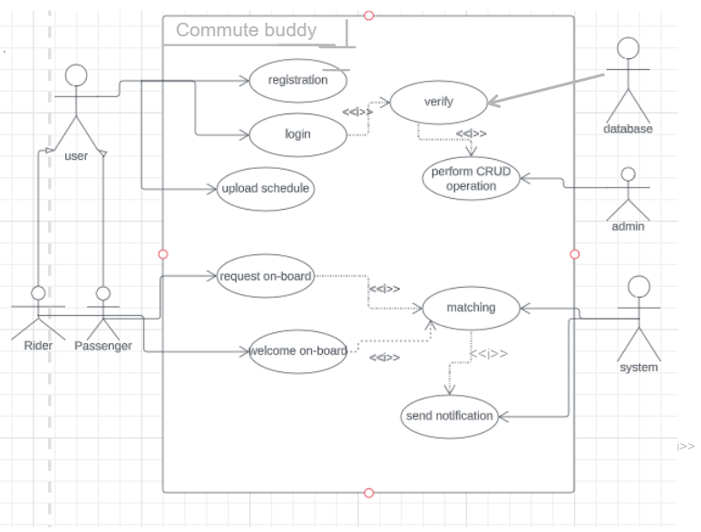

**Class Diagram for Commute Buddy:**

**Activity Diagram for Commute Buddy:**

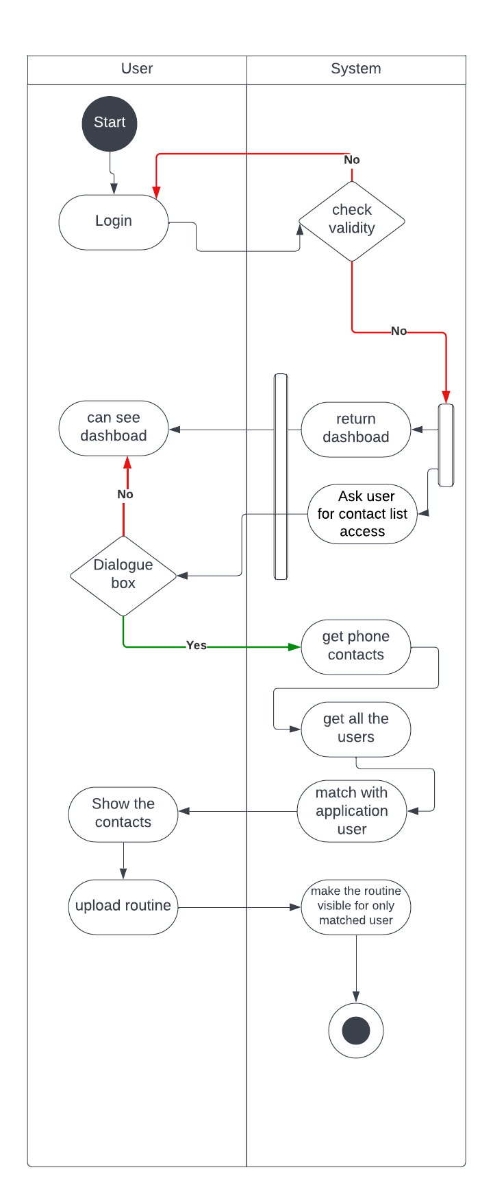

**Sequence Diagram for Commute Buddy:**

